Multi-City Weather Intelligence Dashboard

Introduction
I developed a Multi-City Weather Intelligence Dashboard in Power BI to solve a common problem: weather data is often fragmented and difficult to track across different locations. My goal was to create a centralized, real-time tool that transforms raw API data into actionable insights—such as predicting rain probabilities and monitoring health-critical Air Quality Indices (AQI) across six major Indian cities: Pune, Aurangabad, Bangalore, Hyderabad, Jaipur, and Noida.

1. Data Sourcing & Preparation
For this project, I used the Weather API (http://api.weatherapi.com/v1/forecast.json).
- Data Extraction: I initially pulled data for each of the 6 cities. I then created a Master Table by combining these datasets.
- Data Transformation: Using the Master Table as a reference, I extracted three specialized datasets to cover a 10-day period:
  - Current: Real-time weather conditions.
  - Forecast_day: Daily trends for the next 10 days.
  - Forecast_hour: Granular hourly data for detailed analysis.
- Location Table: I also built a dedicated Location table to store geographical details for all six cities, ensuring data integrity.

2. Data Modelling
After cleaning the data in Power Query (handling null values and standardizing units), I built a Star-Schema-inspired model.
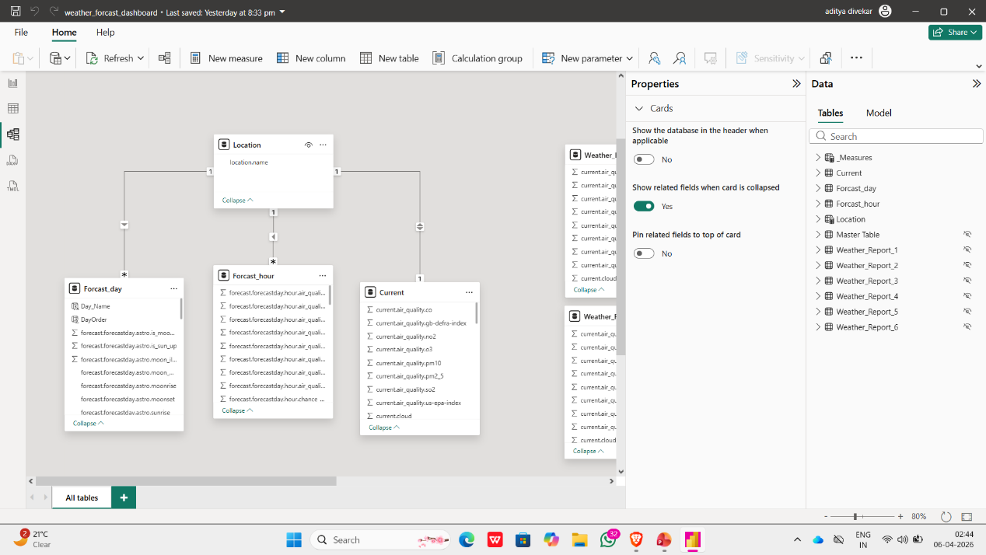
- I created a central Location Table and connected it to the three fact tables: Current, Forecast_day, and Forecast_hour.
- This relationship ensures that when a user selects a specific city, every visual on the dashboard updates automatically to show that city's specific data.

3. Dashboard Walkthrough
A. Current Weather Section (Left Panel)
This section provides an immediate snapshot of the selected city. It displays the current temperature and weather conditions (e.g., "Moderate rain"). I added weather icons to make the information easy to understand at a glance. Below this, I included a City Slicer (button slicer), allowing users to switch between cities instantly.
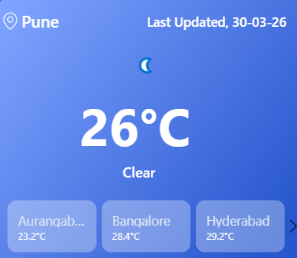

B. 7-Day Forecast Cards (Top Section)
At the top, I used individual cards to show a 7-day outlook. Each card displays the Day Name, Temperature, and a Weather Icon (Sun, Cloud, or Rain). This gives users a quick summary of the upcoming week without them having to analyze a complex chart.
Users can quickly see:
- Which days are sunny
- Which days have clouds or rain
- Temperature for each day
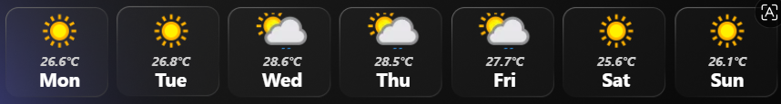

C. Temperature Trend (Line Chart)
In the centre, a Line Chart visualizes the temperature trend for the next 7 days.
- X-Axis shows Day Names | Y-Axis shows Average Forecast Temperature.
- This helps users identify if the week is getting hotter, colder, or remaining stable. For example, I noticed that in many cities, the temperature drops mid-week before stabilizing.

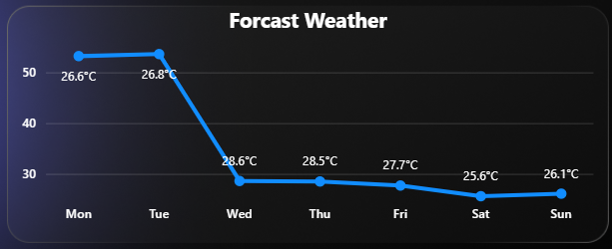

D. Sunrise, Sunset & Astro Data
Next to the chart, I display the exact sunrise and sunset times. I used DAX formulas to format this data into a clean HH:MM format. This adds practical value for people planning outdoor activities or travel.
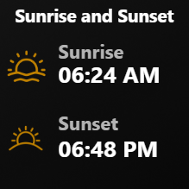

E. Chance of Rain (Bar Chart)
On the right, I included a stacked bar chart showing the "Chance of Rain" in percentage format. The filled part shows how much chance of rain is there
- A high percentage (e.g., 85% or 100%) serves as a clear warning for users to plan for rain. This is one of the most "decision-focused" visuals in the project.
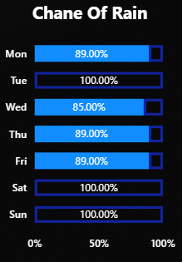
This helps users plan travel or outdoor activities

F. Air Quality Index (AQI) Section
This is a critical health feature. I used cards to show AQI values and created a Dynamic Colour Indicator using DAX. The colors change based on the severity of pollution:
- Green (Good): When the AQI is 50 or below, the indicator turns green, showing the air is clean and safe for everyone.
- Yellow (Moderate): Between 51 and 100, it turns yellow. This means the air quality is acceptable, though there might be a slight risk for very sensitive people.
- Orange/Red (Unhealthy): If the AQI climbs between 101 and 200, the visual shifts to Orange or Red. This is a clear warning that the air is unhealthy and people should start limiting their time outdoors.
- Purple/Maroon (Severe/Hazardous): Anything above 200 triggers a Purple or Dark Maroon alert. This indicates a health emergency where the air is dangerous for everyone, which we often see in highly polluted areas like Noida or Jaipur."
- "By using this color logic, a user doesn't need to be an expert to read the dashboard. They can simply look at the color and know instantly if it’s safe to go for a run or if they should stay indoors.
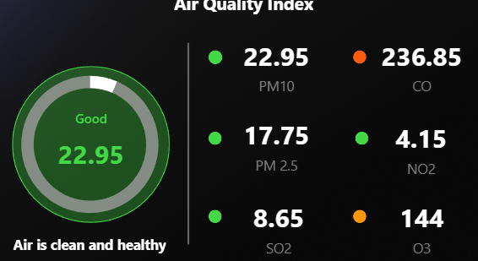

G. Additional Environmental Metrics
At the bottom, I added cards for secondary weather data including Visibility, Humidity, Pressure, Wind Speed, UV Index, and Precipitation. I used DAX to format these with their respective units (e.g., Kph, %, or mb) to provide a 360-degree environmental view
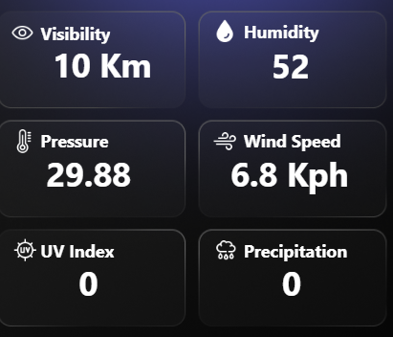

4. Key Insights & Observations
Through this dashboard, I observed several interesting patterns:
- Regional Variation: Cities like Hyderabad consistently show higher temperatures compared to Pune or Bangalore.
- Weather Patterns: Rain probability is currently high across multiple cities, indicating a seasonal trend.
- Health Alerts: Air quality varies significantly; while some cities remain in the "Good" zone, others like Noida frequently hit "Hazardous" levels.
- Weekly Trends: Most cities experienced a slight temperature dip during the middle of the week.

5. Challenges Faced
- Data Cleaning: managing null and duplicates values required careful transformation in Power Query.
- DAX Complexity: Writing DAX measures for dynamic color formatting (AQI) and unit formatting was challenging but necessary for a professional look.
- Modeling: Ensuring the relationships between the Hourly, Daily, and Current tables were accurate to prevent data ambiguity.

6. Conclusion
This project demonstrates my end-to-end capability as a Data Analyst. I successfully managed the entire pipeline: fetching live API data, performing complex Power Query transformations, building a robust data model, and designing an interactive, decision-support dashboard. It proves that I can turn raw, complex data into a simple, user-friendly tool for real-world decision-making.

